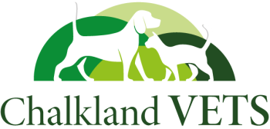

Refer & Reward Scheme!

CV01

Voucher No:



Invite a friend and you’ll both receive a £15 credit!

For further assistance, contact us at [**enquiries@chalklandvets.co.uk**](mailto:enquiries@chalklandvets.co.uk) or on **01249588805**

Please tick which branch you collected this voucher from:

Chippenham

Calne

Corsham

Melksham

Name:

Address:

Postcode:

Phone No:

Pets Name:

Just fill in your details below and give this voucher to a friend.

When they bring it to their pet’s first appointment, you’ll each get a £15 credit added to your account.

**How It Works:**

Invite a friend or family member to our practice and you’ll both receive a £15 credit as a thank you.